Preliminary Design Review Report

ENGR 290-N
Introductory Engineering Team Design Project
Preliminary Design Review Report

Minh-Tri Nguyen, 40317639
Radmehr Mahmoudi, 40278154
Bryce Orchard, 40336764
Parsa Morshedlou, 40316310
Elouan Besnier, 40311078
Ethan Ekollo Dooh, 40328617

Instructor: Khashayar Khorasani
Date Due: October 26th, 2026

“I certify that this submission is my original work and meets the Faculty’s Expectations of Originality”
Minh-Tri Nguyen
October 25th, 2026

Abstract 5
Introduction 5
Overview 5
Objectives 6
Requirements 6
Competition Requirements 6
Score Calculation 6
Design 1 8
Technical Description 8
Hovercraft Architecture and Subsystems 9
Propulsion and Directional Control 9
Skirt Aerodynamics and Stability 10
Autonomous Navigation Suite 10
Sensor Selection Rationale: Ultrasonic and Infrared Integration 11
Power Distribution and Mass Balancing 12
Calculations 13
Modeling Assumptions 13
Mathematical Evaluation 13
Component Mass Estimates 13
Center of Mass and Stability Analysis 14
Lift Performance 15
Propulsion Kinematics and Performance Metrics 17
Linear Dynamics 18
Rotational Dynamics 19
Geometrical Optimization 21
Competition Score Evaluation 22
Mathematical Evaluation Summary 23
Design 2 24
Technical Description 24
Structure Design 25
Lift System 25
Propulsion and Steering 25
Sensors and Control 25
Power and Weight Distribution 26
Mathematical Evaluation 26
Component Mass Estimates 26
Center of Mass and Stability 27
Lift check 28
Moment of inertia 29
Propulsion Kinematics and Performance Metrics 29
Linear Dynamics 30
Rotational Dynamics 31
Design 3 34
Technical description 34
Chassis design 35
Lift system 35
Propulsion system 35
Skirt design 36
Navigation system 36
Sensor choice 37
Calculation 38
Component mass estimate 38
Center of Mass 38
Moment of inertia 39
Electrical system 41
Propulsion Kinematics and Performance Metrics 41
Straight line motion 42
Angular motion 42
Design Selection 44
Constraint Screening 46
SWOT Analysis 46
Design 1 47
Design 2 48
Design 3 48
Key Observations 49
WOT Analysis 50
Justification of Scores 53
Kinematic Cross-Check 54
Sensitivity of the Result 55
Strategies for the Selected Design 55
AHP Analysis 56
Criterion Weights 56
Design Comparisons 57
Synthesis 58
Progress to Date 59
Progress per Area 59
Research and Brainstorming 60
Modeling and Simulation 60
Construction 60
Programming and Software Architecture 61
Technical Documentation 61
Meeting 61
Project Management 64
Current Status 64
Historical Performance 65
Summary 66

Abstract
This project is to make an autonomous hovercraft capable of navigating a maze using onboard sensors to gather data and make adjustments to its course. The design must provide vertical thrust to float, overcome obstacles, and turn on corners without outside influence. The engineering objective is to complete the course whilst optimizing completion time and component count. The preliminary design review establishes the mission objectives, requirements, architecture, specifications and a basis for evaluating proposed alternatives.
The current design direction uses a dedicated lift fan, a thrust fan combined with a servo-motor , a lightweight foam structure, and a flexible skirt. Range sensors detect the course geometry, while an IMU supports yaw-rate feedback. An arduino based controller coordinates sensing and actuator commands. Three alternatives have been proposed. The supplied design record contains detailed descriptions and preliminary calculations for design 2 and 3. The team has provisionally adopted Design 3, while the final selection depends on the complete three-design comparison.
The remaining development work includes reconciling the component and power budgets, verifying the lift operating point and turning envelope, integrating the navigation code, testing the assembled craft. The calculations in this review are preliminary design estimates. They establish what must be checked during implementation and do not constitute measured competition performance.

Introduction

Overview
A hovercraft carries its weight on a cushion of air typically via a vertical thrust fan. The said fan replenishes air escaping around the skirt, while a separate thrust system moves and steers the craft. The low resistance to motion allows a small thrust force to accelerate the vehicle, but it also makes stopping and preventing sideways drift especially challenging. Hence, our design treats lift, steering, sensing, power distribution and resource management as an integrated system.
The PDR is the decision point between preliminary design and detailed implementation. It must show that the proposed device achieves the objectives. Before implementation, our team must have at least tree alternative designs, quantitative comparisons, SWOT, WOT, and AHP analysis, progress against a design process and a Gantt chart.

Objectives
Our primary objective is autonomous completion of the maze in a timely manner. A fast device that gets stuck in a corner or misses its stop does not satisfy the objective. The mechanical design must support the entire device mass, keep the weight distribution compatible with the air cushion and float during the entirety of the course.
This PDR report’s objective is to choose from three distinct, yet comparable designs. Comparison is done using common performance metrics and test conditions. CAD models and analytical estimates support the comparison.

Requirements

Competition Requirements
The design requirements define the functions that the hovercraft must perform and the limits within which it must function. The requirements are independent. Battery power, area and additional sensors can improve individual tasks but they also increase overall mass, size and component count. Their combined effect determines the suitability for the design.
The following requirements determine whether objectives are met:
- The device must navigate the maze autonomously
- Device height must not exceed 50cm
- Device must overcome obstacles ranging from 1 to 3 mm
- Object must turn to navigate and exit the maze
- Object must detect and stop before a randomly placed bar
- Finishing the course without fully discharging the battery

Score Calculation
The scores are calculated by simply dividing the traveled distance by the product of the number of components and the time it took to complete the course.
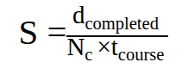
- d_{Completed} : the distance traveled
- N_{C} : number of components
- t_{course} : the time to complete the maze
This scoring formula rewards fewer component usage and speed. Reliable completion remains the primary objective because a reduction in number of components or higher speed is only beneficial when the device can navigate the maze successfully.

Design 1
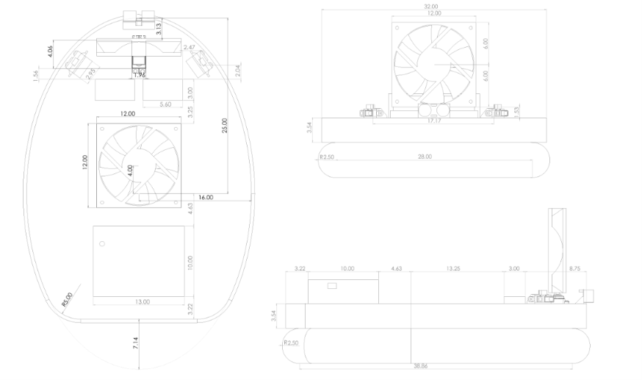

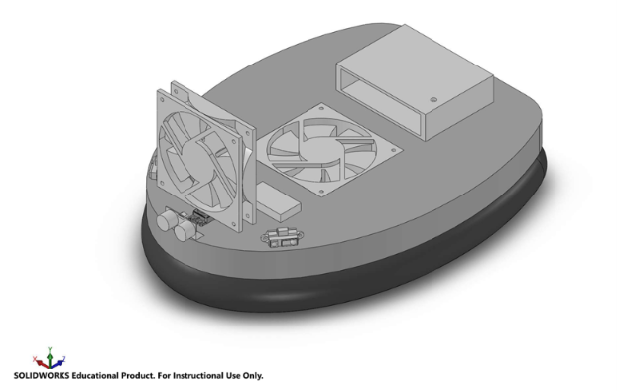

Technical Description
The objective of Design 1 is to develop a maneuverable and stable hovercraft capable of navigating the competition track efficiently. As illustrated above, the design features a rounded chassis with a centrally positioned lift fan and a front-mounted thrust fan controlled by a servomotor. The rounded geometry was selected to reduce the risk of collisions with the track walls during tight turns, while the thrust-vectoring system provides both propulsion and directional control.
The design has a width of 320 mm and a length of 388.6 mm, with an estimated total mass of 0.769 kg. Its navigation system includes two infrared sensors, one ultrasonic sensor, and an inertial measurement unit (IMU).

Hovercraft Architecture and Subsystems
The physical structure of Design 1 consists of a lightweight Styrofoam chassis with a rounded perimeter. Unlike conventional rectangular configurations, the curved shape reduces the likelihood of the hovercraft becoming caught against the competition walls during rotation. It also provides a more compact turning envelope, which is advantageous for navigating the 50–55 cm wide track.
The lift fan is mounted near the geometric center of the chassis to provide a relatively balanced air cushion. The thrust fan is installed at the front, while the controller is positioned toward the rear to partially offset the mass of the propulsion assembly. The two Li-Po batteries are arranged symmetrically to reduce lateral mass imbalance.
Based on the MATLAB geometric simulation, the rounded chassis has an estimated spin diameter of 408 mm. For a 500 mm lane, the theoretical turning clearance is:
$c=\frac{W_{lane}-D_{spin}}{2}$
$c=\frac{500-408}{2}$
This calculation assumes rotation about the geometric center without additional component protrusions. The actual operating footprint must comply with the competition's 480 mm maximum dimension.

Propulsion and Directional Control
The propulsion system consists of two fans, each serving a distinct function. The Delta AFB1212SH is selected for lift due to its maximum static pressure of 107.1 Pa and airflow of 113.1 CFM at 12 V. These specifications make it suitable for generating and maintaining the air cushion beneath the chassis.
Forward movement is provided by the Sunon MEC0251V1 thrust fan, selected for its high airflow-to-mass ratio. With an airflow of 108.2 CFM and a mass of 162 g, this fan provides theoretical propulsion while limiting the overall vehicle mass.
Unlike a rear-mounted configuration, the thrust fan is positioned at the front and connected to a servomotor. The servo changes the thrust direction, producing a lateral force and corresponding torque about the center of mass. This eliminates the need for a separate rudder system.
The MATLAB simulation estimates a thrust force of 0.297 N and an idealized initial linear acceleration of 0.386 m/s².

Skirt Aerodynamics and Stability
The hovercraft uses a lightweight polyethylene skirt to retain pressurized air beneath the chassis. The skirt provides the air cushion necessary to reduce direct contact with the ground and minimize friction.
The rounded perimeter reduces sharp corners where the skirt could become caught against obstacles or track walls. However, the skirt must be properly sealed to prevent excessive leakage.
According to the MATLAB model, the required cushion pressure is approximately 72.6 Pa, below the Delta AFB1212SH's maximum reference pressure of 107.1 Pa at 12 V. The estimated hover gap is 2.17 mm at 12 V, increasing to approximately 3.77 mm under a hypothetical 13.8 V fan-performance scenario.
The higher-voltage result is a sensitivity estimate rather than a validated operating condition. Physical testing is required to verify obstacle clearance and fan compatibility.

Autonomous Navigation Suite
The hovercraft uses an Arduino-based controller to process sensor measurements and adjust the fans and steering servomotor. Its navigation system consists of two infrared sensors, one ultrasonic sensor, and one IMU.
The two IR sensors are mounted diagonally near the front of the chassis. Their purpose is to measure proximity to the surrounding walls and provide feedback for maintaining the hovercraft's position within the track. Their angled arrangement supports the detection of nearby corners and openings.
The ultrasonic sensor is positioned at the front, near the thrust-fan assembly. This location provides an early distance measurement before the main chassis reaches an obstacle. Its orientation must be verified for the overhead-bar detection task, and its field of view must remain unobstructed.
The GY-521 IMU contains an accelerometer and gyroscope that measure acceleration and angular velocity. It is particularly useful for detecting unwanted rotational movement during straight-line motion. By providing angular-rate feedback, the IMU allows the controller to correct steering and reduce heading drift.
During 90° and 180° turns, the IMU can also assist in estimating angular displacement and reducing overshoot.

Sensor Selection Rationale: Ultrasonic and Infrared Integration
The IR sensors were selected for their relatively fast response and narrow detection area, making them useful for measuring proximity to walls and identifying changes in the surrounding environment.
The ultrasonic sensor complements these measurements by providing distance information without relying primarily on the reflective color of an obstacle. Its front placement is advantageous for detecting an approaching wall or other object.
The IMU measures rotational motion rather than environmental distance. This is important because the air cushion reduces friction, allowing the craft to drift or continue rotating after a steering command.
Together, the sensors provide complementary feedback for wall detection, heading stabilization, and controlled navigation. Their effectiveness must be verified experimentally.

Power Distribution and Mass Balancing
The electrical system is modeled using two Gens Ace 2S 450 mAh Li-Po batteries connected in series, producing a nominal voltage of 14.8 V. The batteries are arranged symmetrically to reduce lateral weight imbalance, while the rear controller partially compensates for the front-mounted thrust assembly.
The total power consumption is estimated by adding the power requirements of the lift fan, thrust fan, and control electronics:
$P_{total}=P_{lift}+P_{thrust}+P_{control}$
$P_{total}=6.36+5.50+4.00$
The estimated current drawn from the battery is:
$I=\frac{P}{V}$
$I=\frac{15.86}{14.8}$
Assuming 80% usable battery energy, the theoretical runtime is:
$t=\frac{0.8VC}{P_{total}}$
$t=\frac{0.8(14.8)(0.45)}{15.86}$
$t≈0.336 h$
Converting to minutes:
$t=0.336(60)$
This is an idealized estimate. Actual battery runtime depends on voltage conversion losses, servo activity, and the operating current of the fans.

Calculations

Modeling Assumptions
The mathematical evaluation assumes that the hovercraft behaves as a rigid body and that most components can be approximated as concentrated masses. An additional inertia estimate is included for the chassis.
The rounded geometry is approximated by a superellipse. The fan pressure-flow relationship is assumed linear, while aerodynamic drag and residual skirt resistance are included in the linear simulation. The rotational simulation uses an idealized bang-bang turning maneuver.
Component masses, electrical loads, aerodynamic coefficients, and fan performance must be experimentally validated.

Mathematical Evaluation
The model evaluates the mass distribution, center of mass, lift performance, propulsion characteristics, and linear and rotational dynamics of Design 1.

Component Mass Estimates
The total mass is determined by adding the individual masses of the structural, electrical, and mechanical components:
$M=\sum_{i=1}^{n}{}m_{i}$
The MATLAB simulation estimates:
$M≈0.769 kg$
The calculation includes the fans, servomotor, batteries, sensors, controller, chassis, skirt, and mounting components.
Table 1. Component Mass Estimates for Design 1.
Component | Model | Estimated mass
Lift fan | Delta AFB1212SH | 198 g
Thrust fan | Sunon MEC0251V1 | 162 g
Servo motor | HS-311 | 43 g
Controller and enclosure | ENGR 290 | 150 g
Batteries (×2) | 25 450 mAh Li-Po | 56 g
Ultrasonic sensor | HC-SR04 | 8.5 g
IR sensors (×2) | Model TBD | 10 g
IMU | GY-521 | 5 g
Fan mount and safety guards | Custom | 20 g
Skirt | Polyethylene | 25 g
Wiring and fasteners | Miscellaneous | 30 g
Foam chassis | Estimated density | Calculated
Total |  | ≃769 g
The component masses are preliminary values and will be replaced with measured values when constructing the prototype.

Center of Mass and Stability Analysis
The center of mass is determined using the weighted average of each component's position:
$x_{COM}=\frac{\sum_{i}{}m_{i}x_{i}}{M}$
$y_{COM}=\frac{\sum_{i}{}m_{i}y_{i}}{M}$
The MATLAB simulation estimates:
$x_{COM}≈19.7 mm$
$y_{COM}≈0 mm$
The center of mass is slightly ahead of the geometric center because of the front-mounted thrust fan and servomotor. The lateral offset is approximately zero due to the symmetrical battery arrangement.
The moment of inertia about the vertical axis is:
$I_{zz}=\sum_{i}{}m_{i}r_{i}^{2}+I_{deck}$
The estimated result is:
$I_{zz}= 0.00859 kgm^{2}$
A relatively low moment of inertia improves rotational response by allowing greater angular acceleration for a given torque.

Lift Performance
The lift force must support the full weight of the hovercraft:
$F_{L}=Mg$
The required cushion pressure is:
$P_{c}=\frac{Mg}{A_{c}}$
The MATLAB simulation gives:
$P_{c}≈72.6 Pa$
The Delta AFB1212SH fan provides a reference maximum static pressure of 107.1 Pa at 12 V. Therefore, the required pressure represents:
$\frac{72.6}{107.1}×100$
The operating airflow is calculated using the simplified fan curve:
$Q_{op}=Q_{\max_{}}\left(1-\frac{P_{c}}{P_{\max_{}}}\right)$
The estimated hover gap is:
$h=\frac{Q_{op}}{C_{d}P_{skirt}\sqrt{\frac{2P_{c}}{ρ}}}$
The simulation predicts:
$h_{12V}≈2.17 mm$
For the hypothetical 13.8 V sensitivity case:
$h_{13.8V}≈3.77 mm$
The hover-gap graph demonstrates that increasing the hovercraft's total mass reduces the available leakage gap, emphasizing the importance of minimizing weight.
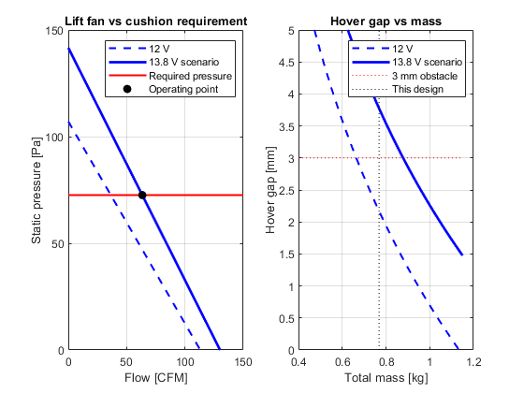
Figure 1. Lift Fan Performance and Hover Gap as a Function of Mass.

Propulsion Kinematics and Performance Metrics
The thrust force is estimated using momentum theory:
$F_{T}=kρQv$
The airflow of the Sunon MEC0251V1 is:
$Q=108.2(0.000471947)$
The effective outlet area is:
$A=\frac{π}{4}(d_{tip}^{2}-d_{hub}^{2})$
$A=\frac{π}{4}(0.116^{2}-0.045^{2})$
The estimated jet velocity is:
$v=\frac{Q}{A}$
$v=\frac{0.05107}{0.00898}$
Using air density $ρ=1.204 kg/m^{3}$ and an assumed correction factor $k=0.85$:
$F_{T}=0.85(1.204)(0.05107)(5.69)$
When the thrust fan is deflected by an angle $δ$, its force components are:
$F_{x}=F_{T}cosδ$
$F_{y}=F_{T}sinδ$
The MATLAB results show that forward acceleration reaches its maximum when the fan points directly backward, while yaw acceleration increases in magnitude as the thrust is redirected laterally.
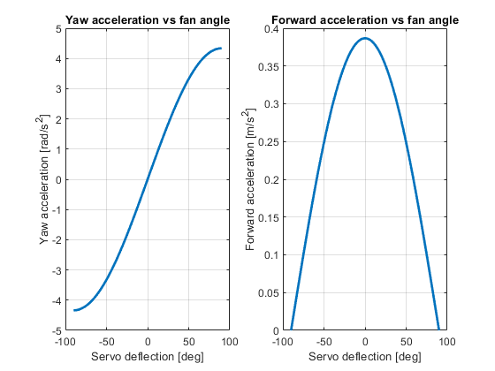
Figure 2. Forward and Yaw Acceleration versus Servo Deflection.

Linear Dynamics
The idealized initial forward acceleration follows Newton's Second Law:
$F=Ma$
$a=\frac{F}{M}$
Substituting:
$a=\frac{0.297}{0.769}$
For a more representative prediction, the MATLAB model includes aerodynamic drag and residual skirt resistance:
$M\frac{dv}{dt}=F_{T}-F_{drag}-F_{skirt}$
Aerodynamic drag is approximated as:
$F_{drag}=\frac{1}{2}ρC_{D}A_{f}v^{2}$
Therefore:
$\frac{dv}{dt}=\frac{F_{T}-\frac{1}{2}ρC_{D}A_{f}v^{2}-F_{skirt}}{M}$
The displacement is calculated by numerical integration of the velocity:
$\frac{dx}{dt}=v$
For the 2.35 m straight section, the MATLAB simulation predicts:
$t≈4.11 s$
The displacement graph shows progressively increasing distance, while the velocity graph indicates increasing forward speed throughout the straight-line simulation.

Rotational Dynamics
The front-mounted thrust fan generates torque by applying a lateral force at a distance from the center of mass.
The torque is expressed as:
$τ_{z}=(x_{T}-x_{COM})F_{y}-(y_{T}-y_{COM})F_{x}$
For a thrust fan mounted along the longitudinal centerline:
$τ_{z}≈rF_{T}sinδ$
The angular acceleration follows the rotational form of Newton's Second Law:
$τ_{z}=I_{zz}α$
$α=\frac{τ_{z}}{I_{zz}}$
The MATLAB model estimates a maximum idealized angular acceleration of approximately:
The rotational simulation evaluates a 180° turn using a bang-bang control approach. During the first half of the turn, positive angular acceleration increases the yaw rate. During the second half, the torque is reversed to decrease the angular velocity until the hovercraft reaches the required orientation.
The time-response curves demonstrate the theoretical ability to perform a controlled turn. In practice, IMU feedback would help the controller compensate for disturbances and reduce overshoot.
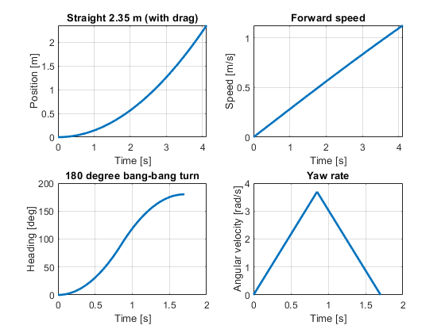
Figure 3. Linear Displacement, Forward Velocity, Angular Position, and Yaw Rate.

Geometrical Optimization
The MATLAB simulation evaluates the effect of chassis dimensions on hover gap and turning diameter.
Increasing the chassis area can reduce the pressure required to support the same mass. However, larger dimensions may also increase the mass of the structure and the space required for rotation.
The rounded chassis has a modeled spin diameter of approximately:

$D_{spin}≈408 mm$
This produces theoretical clearance of approximately 46 mm on either side of a 500 mm lane under idealized centered rotation.
$c=\frac{500-408}{2}$
$c≈46 mm/side$
The size-trade simulation demonstrates the relationship between lift performance and maneuverability, highlighting the importance of selecting dimensions that balance cushion area against turning space.
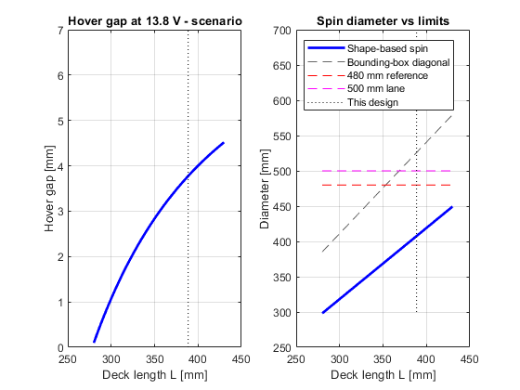
Figure 4. Chassis Length versus Hover Gap and Turning Diameter.

Competition Score Evaluation
The competition score is based on the completed distance, counted components, and completion time:
$S=\frac{d}{N_{c}t}×B$
where $d$ is the completed distance, $N_{c}$ is the number of counted components, $t$ is the course time, and $B$ represents applicable bonuses.
The MATLAB model compares five hypothetical sensor configurations under two finishing scenarios. These results illustrate the impact of component count and travel time on the theoretical competition score.
The plotted scores are illustrative rather than validated predictions from an autonomous course simulation.
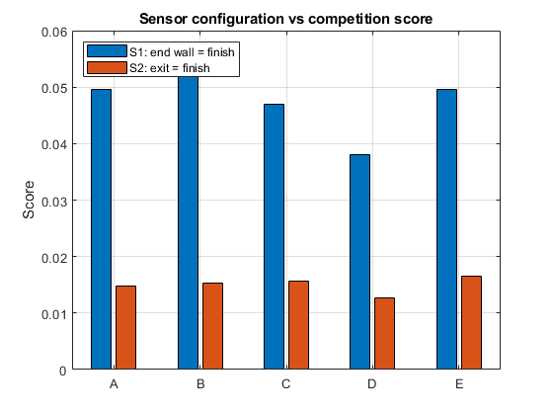
Figure 5. Sensor Configuration versus Competition Score.

Mathematical Evaluation Summary
Quantity | Estimated value
Total mass | 0.769 kg
Center of mass | (+19.7, 0) mm
Moment of inertia | 0.00859 kg·m²
Required cushion pressure | 72.6 Pa
Hover gap at 12 V | 2.17 mm
Hover gap at 13.8 V, hypothetical | 3.77 mm
Thrust force | 0.297 N
Initial forward acceleration | 0.386 m/s²
Travel time over 2.35 m | 4.11 s
Maximum idealized angular acceleration | ≈4.3 rad/s²
Spin diameter | 408 mm
Estimated electrical power | 15.86 W
Battery runtime | 20.2 min

Design 2

Technical Description
Design 2 is a long, narrow hovercraft built mainly for fast straight-line travel. The competition track is mostly 2.35 m straightaways, so the team chose a shape that favours speed and directional stability on the straights over very tight turning. Steering comes from a single servo-mounted thrust fan, so one fan handles both forward motion and turning.
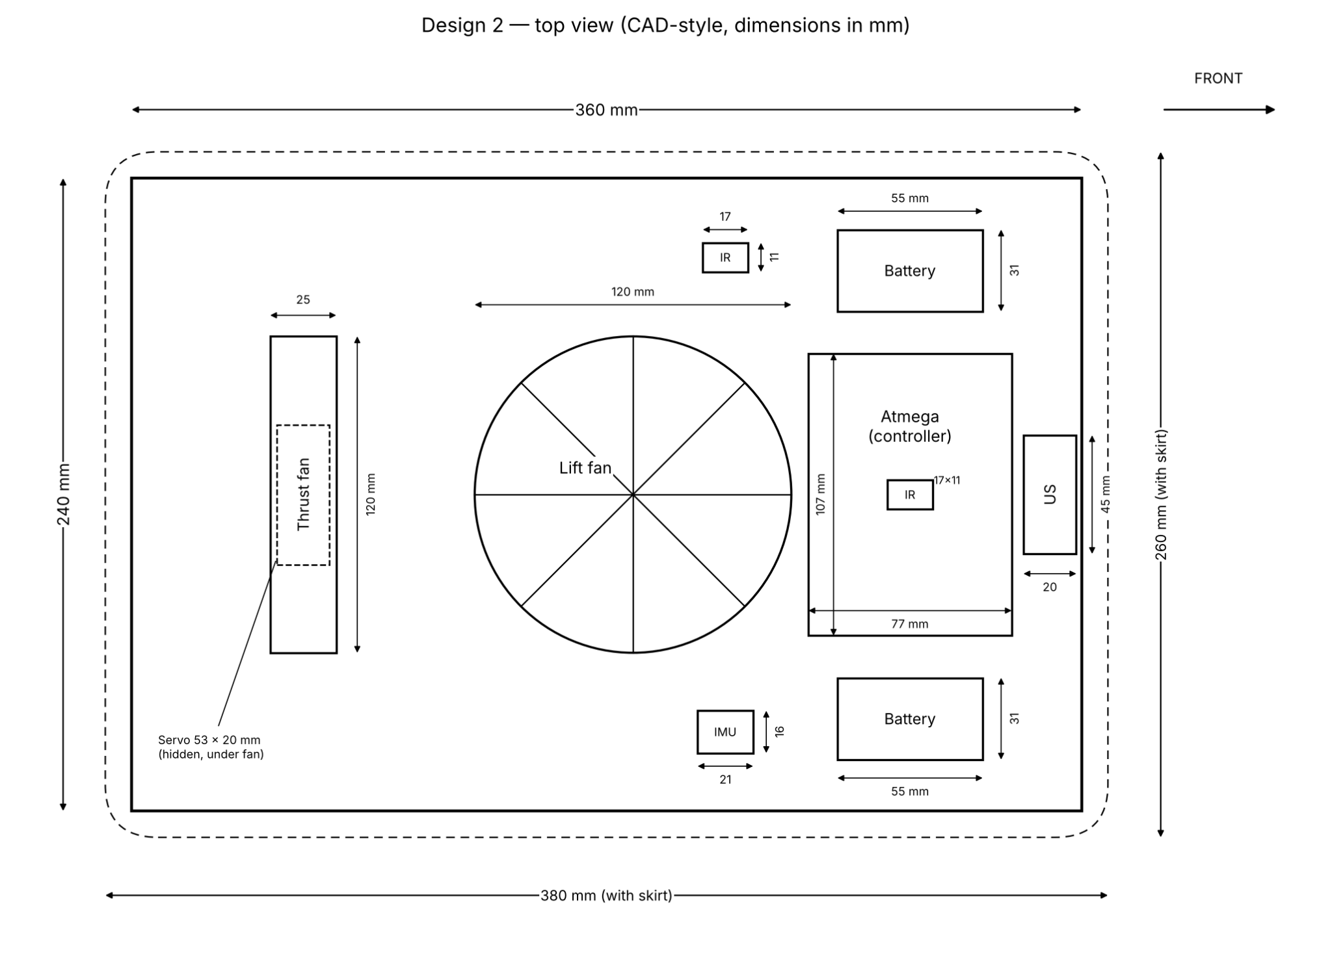
Figure 6. Top view schematic

Structure Design
Design 2’s shape comes from drag-racing cars, which are long and narrow so they can go fast in a straight line. Most of the track is 2.35 m straight sections, so Design 2 uses a simple rectangular foam deck of 360 × 240 mm (a 1.5 : 1 ratio). The narrow front lowers air drag, and the long body helps the craft keep a straight path. With the skirt, the craft measures 380 × 260 mm. Its diagonal is 460 mm, which is under the 480 mm limit. The trade-off is that a long body is a little harder to rotate, so the craft turns corners slightly more slowly.

Lift System
A single Delta AFB1212SH fan near the centre of the deck lifts the craft. This fan was chosen because it has the highest static pressure of the available fans, and pressure is what holds the craft up. The fan blows air under the deck, and the skirt traps that air to form a cushion. The skirt is made from polyethylene bag material because it is light (about 20 g), airtight, and flexible enough to pass over the 1–3 mm obstacles. It sticks out 10 mm past the deck and has rounded corners, so it inflates evenly and doesn’t catch on the walls.

Propulsion and Steering
One Sunon thrust fan at the rear both pushes and steers the craft. It sits on an HS-311 servo that can turn the fan up to ±90°. When the fan points straight back, the craft moves forward. When the servo turns the fan to the side, the thrust pushes the back of the craft sideways and the craft turns. The fan is 118 mm behind the centre of mass, so even a small thrust gives a strong turning effect. Using one fan instead of two saves weight and power. The fan’s pivot is 65 mm from the rear edge, so the fan never sticks out past the deck when it swings.

Sensors and Control
An ATmega controller reads the sensors and controls the two fans and the servo. Each sensor has one job on the track, as shown in Table 2.

Table 2. Design 2 sensors
Sensor | Position (x, y) mm | Size (mm) | Purpose | Reason for choice
Ultrasonic (HC-SR04) | (168, 0), front | 45 × 20 | Detects obstacles ahead | Reliable at medium range and not affected by surface colour
IR, top-facing | (45, 90) | 17 × 11 | Detects the ahead wall and assist the ultrasonic | Small and fast, with a narrow beam
IR, side-facing | (115, 0), on lid | 17 × 11 | Detects the side wall and the exit opening in the last segment | A narrow beam can pick out the gap clearly
IMU (MPU-6050) | (45, −90) | 21 × 16 | Measures heading and rotation rate | Helps keep the craft straight and control turns accurately

Power and Weight Distribution
The craft uses two Gens ace 2S 450 mAh LiPo batteries wired in series to give 14.8 V. They were chosen because each one weighs only 28 g, and a lighter craft hovers higher. Together they give about 15.5 minutes of running time, which is enough for testing and several competition runs. The batteries sit on both sides of the controller, so they balance each other side to side and offset the heavy thrust fan at the rear. As a result, the centre of mass is only 3 mm ahead of the deck centre, and the craft hovers level.

Mathematical Evaluation

Component Mass Estimates
Table 3 lists the mass of every part. The total mass is 0.760 kg. Values marked (est.) are estimates that will be replaced with weighed values once the parts are in hand. Since lift is the tightest margin in this design, the total mass should stay at or below about 0.76 kg.

Table 3. Design 2 mass budget
Component | Model | Mass (g)
Lift fan | Delta AFB1212SH | 198
Thrust fan | Sunon MEC0251V1-000U-A99 | 162
Servo motor | HiTec HS-311 | 43
Controller + enclosure | ATmega | 150 (est.)
Batteries (×2) | Gens ace 2S 450 mAh LiPo | 56
Ultrasonic sensor | HC-SR04 | 8.5
IR sensors (×2) | Sharp GP2Y0A21YK0F | 10
IMU | GY-521 (MPU-6050) | 5
Deck (minus fan hole) | Foam board, 20 mm | 49.5
Skirt | Polyethylene bag | 20 (est.)
Fan–servo bracket | — | 12 (est.)
Fan safety nets (×2) | — | 16 (est.)
Wiring, glue, tape | — | 30 (est.)
Total |  | 760

Center of Mass and Stability
The centre of mass (COM) of the hovercraft is found by multiplying each part’s mass by its position, adding these up, and dividing by the total mass:
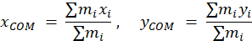

Table 4. Component positions measured from the deck centre
Component | m (g) | x (mm) | y (mm)
Lift fan | 198 | 10 | 0
Thrust fan + servo + bracket | 217 | −115 | 0
Fan safety nets | 16 | −52.5 | 0
Controller | 150 | 115 | 0
Battery A | 28 | 115 | 85
Battery B | 28 | 115 | −85
Ultrasonic sensor | 8.5 | 168 | 0
IR sensor (side) | 5 | 115 | 0
IR sensor (top) | 5 | 45 | 90
IMU | 5 | 45 | −90
Deck, skirt, wiring | 99.5 | ≈0 | 0
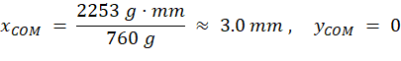
The two batteries are placed at y = +85 mm and y = −85 mm, so they cancel each other and the COM stays exactly on the centreline. The heavy electronics at the front balance the thrust fan and servo at the rear, so the COM ends up only 3 mm in front of the centre of lift. Because the weight sits almost exactly over the centre of the air cushion, the cushion pressure stays even and the craft hovers level instead of tipping forward or backward.

Lift check
The maximum static pressure of the Delta AFB1212SH lift fan is 107.1 Pa at its rated 12 V, measured at zero airflow. Since the fan is driven at 13.8 V, the top of its rated 13.8 V operating range, its maximum pressure is estimated using the fan affinity laws. These assume fan speed is proportional to voltage and pressure is proportional to the square of speed:
$p_{max}(13.8V)=107.1{\left(\frac{13.8}{12}\right)}^{2}=107.1(1.3225)=141.6 Pa$
To hover, the air pressure under the hull must hold up the full weight of the craft. The pressure needed is the weight divided by the deck area (0.36 m × 0.24 m = 0.0864 m²):
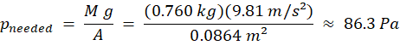
The craft therefore needs only 86.3 / 141.6 ≈ 61 % of what the fan can give, so the fan is strong enough to lift it with some margin left.

Moment of inertia
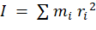
where r is each part’s distance from the COM. Large parts such as the deck, the fans and the controller also resist rotation because of their own size, so their own inertia is added on top.
Table 5. Moment of inertia about the centre of mass
Component group | m (g) | r from COM (mm) | m·r² (×10⁻⁴ kg·m²) | Incl. own size (×10⁻⁴ kg·m²)
Thrust fan + servo + bracket | 217 | 118 | 30.2 | 32.4
Controller | 150 | 112 | 18.8 | 21.0
Batteries (×2) | 56 | 141 | 11.1 | 11.3
Lift fan | 198 | 7 | 0.1 | 3.7
Deck, skirt, wiring | 99.5 | ≈3 | 0.0 | 15.6
Sensors + safety nets | 39.5 | various | 4.4 | 4.5
Total | 760 |  | 64.6 | 88.3
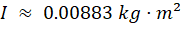
The thrust module at the rear is the largest contributor, because it is both heavy and the farthest part from the COM.

Propulsion Kinematics and Performance Metrics
The single rear thrust fan moves the craft forward and also turns it. The fan pushes air backward, and by Newton’s third law the air pushes the craft forward. The thrust force is estimated from how much air the fan moves and how fast that air leaves the fan.
The fan moves Q = 108.2 CFM = 0.05107 m³/s of air. The air leaves through the ring between the blade tips (116 mm) and the hub (45 mm), which has an area of:
The speed of the air leaving the fan is the airflow divided by this area:
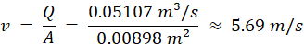
The thrust is the air density (ρ = 1.204 kg/m³) times the airflow times the air speed.
$ρ=\frac{p}{R_{specific}T}$
$ρ=\frac{101325}{287.05×293.15}=\frac{101325}{84149}≈1.204 kg/m^{3}$
A factor k = 0.85 is used to account for losses in the real fan:
The thrust fan is located at x = −115 mm and the COM is at x = 3 mm, so the fan acts 118 mm (0.118 m) behind the COM. This distance is the lever arm used for turning.

Linear Dynamics
When the fan points straight back, all of its thrust pushes the craft forward. Since friction is neglected, Newton’s second law (F = ma) gives the acceleration directly:
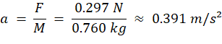
The craft starts from rest and speeds up at a constant rate. The distance it travels is d = ½ a t². Solving for time, the time to cover the 2.35 m straight section is:
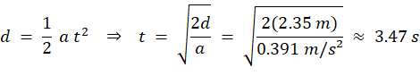
The speed at the end of the straight section is:

Rotational Dynamics
To turn, the servo rotates the thrust fan sideways (90°). The thrust now pushes the back of the craft sideways, which creates a torque around the COM. Torque is the force times the lever arm:
The rotational version of F = ma is τ = Iα, so the angular acceleration is:
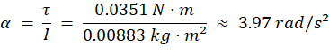
The turn works the same way as the straight-line motion, using angles instead of distances. Starting from rest, the time for a 90° (π/2 rad) turn is:
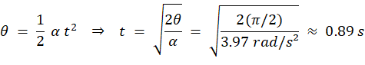
In practice, the craft should stop rotating once it reaches 90°. If the fan is swung to the other side halfway through the turn, the craft speeds up for the first 45° and slows down for the last 45°. Each half takes about 0.63 s, so a complete rest-to-rest 90° turn takes about 1.26 s.

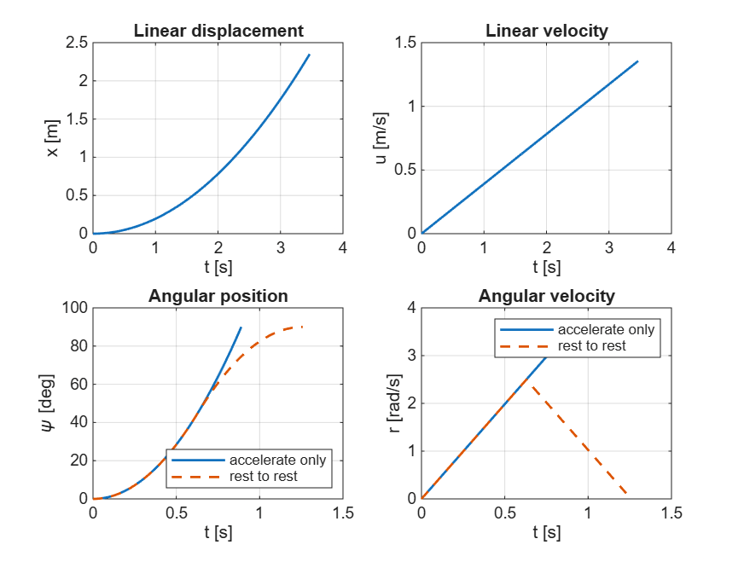
Table 6. Design 2 mathematical evaluation summary
Quantity | Value
Total mass, M | 0.760 kg
Centre of mass | (3.0, 0) mm
Moment of inertia, I | 0.00883 kg·m²
Pressure needed / fan maximum | 86.3 / 141.6 Pa (61 %)
Thrust force, F | 0.297 N
Linear acceleration, a | 0.391 m/s²
Time for 2.35 m straight | 3.47 s (1.36 m/s at the end)
Turning torque, τ | 0.0351 N·m
Angular acceleration, α | 3.97 rad/s²
Time for 90° turn | 0.89 s (1.26 s rest to rest)
Battery run time | ≈ 15.5 min

Design 3

Technical description
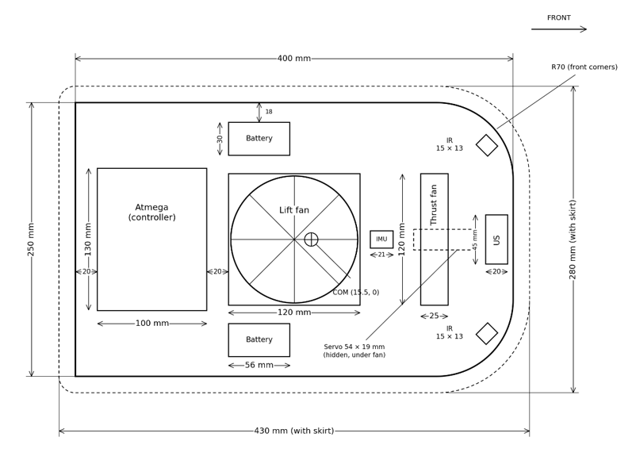
The goal of this design was to have a fast hovercraft at the cost of more components. Since the track has many corners, focusing on fast handling of these elements of the track is essential. The design visible below uses 2 fans, 1 thrust and 1 lift, to move the system.
Figure 7: top front side view of the design 3

Chassis design
The chassis of the hovercraft is in the shape of a rectangle with rounded corners. The front is built so that contact with a wall will be less likely to push or block the hovercraft in a certain direction. The rear is rectangular however, since the fan cannot handle reverse trust and it is not required to go backward.

Lift system
The lift of the hovercraft will be handled by the fan AFB1212SH, which has very good pressurization metrics with a maximum static pressure of 107.1 Pa and a very good airflow value of 113.11 CFM. This will ensure that the skirt inflates at a decent speed and reaches the desired pressure to lift the hovercraft.

Propulsion system
The second fan, which is responsible for propulsion, is the MEC0251V1, which offers a better CFM to weight ratio than the 2 others.

 | MEC0251V1 | ADB1212SH | CFM-A238V
masse | 0.162 | 0.198 | 0.218
Airflow | 108.2 | 113.1 | 138
airflow/masse | 666.67 | 570.71 | 633.03
Table 7: airflow masse ratio for all the fans
Since the track is made out of a lot of corners, the lower airflow will generate a more controllable behavior in the corner while having a small impact on the performance in straight line speed.
The steering will be done by the servomotor, which will use the feedback from the IMU in a straight line to correct the drift. It will also use the feedback of the 2 IR’s to maintain itself in the center of the track and manage the corners

.

Skirt design
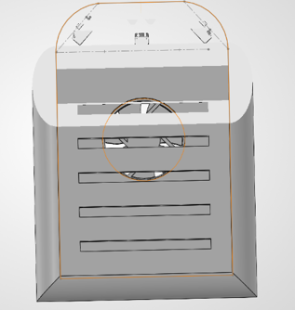
The skirt will be built with 2 layers of strong garbage bags. The top and bottom plates are both solid and made from dense Styrofoam, with the top plate holding all the external components and the bottom plate having rectangular holes spaced equally to let out the air. Having the bottom plate ensures that the skirt is not damaged by friction with the ground and ensures an evener spread. The skirt will be attached to the 2 plates and will separate the 2 plates when inflating.
Figure 8: Bottom view with an angled cut of design 3

Navigation system
This design uses 4 sensors for the navigation system.
2 infrared sensors at a 45-degree angle at the front of the hovercraft. They are responsible for evaluating where the model is between the 2 walls to stay relatively centered. It also detects where an opening appears on either side, allowing it to detect the final randomly placed opening as well as the turns that need to be taken and provide feedback while making said turns.
1 ultrasonic sensor at the front, placed at an angle looking up. This sensor is responsible for the detection of the overhead object that requires the hovercraft to come to a stop.
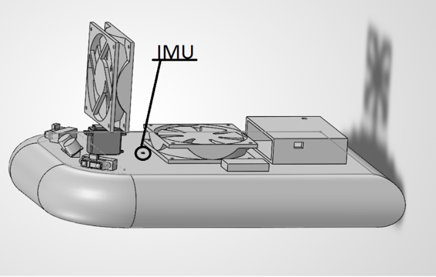
1 IMU right behind the servomotor. This sensor is responsible for evaluating the rotation of the hovercraft around the point of contact between the servomotor and the fan, which is where the torque applied on the design is generated. This will enable the detection of drift and allow the thrust fan to correct its direction to compensate for it.
Figure 9: front side view of design 3

Sensor choice
The 2 IR sensors were chosen for their fast reaction time and their capacity to handle corner more easily. Since they will always detect within range, their behavior after 80 cm can be ignored.
The US sensor was chosen because it looks up. It will detect nothing until the overhead sign is reached. The IRs can have unpredictable behavior when they do not detect any object within range, so choosing a US sensor is the wiser choice.

Calculation

Component mass estimate
First, the following table shows the mass of design 3
Components | ID | mass (g)
Thrust fan | MEC0251V1 | 162
Lift fan | AFB1212SH | 198
Servomotor | HS-422 | 45.5
Left IR sensor | GP2Y0A21YK | 3.6
Right IR sensor | GP2Y0A21YK | 3.6
Controller |  | 150
Left battery | Gens Ace 450mA 2S | 28
Right battery | Gens Ace 450mA 2S | 28
IMU | GY-521 (MPU-6050) | ≈ 5
US sensor | HC-SR04 | 8.5
Styrofoam base(assuming high density) |  | 37.6
Skirt |  | 5 (assumption)
Wires, net, brackets |  | 30+12+16=58g
table 8: components weight of design 3
The total mass of design 3 is 732.6 g

Center of Mass
For the calculation of center of mass, the origin is at the center of the deck, with the positive value for x being forward and for y being left.
The center of mass of the Y axis is 0 since the design is left right symmetric.
The center of mass of the X axis is 15.5 mm. This value is found through the formula:
with M being the total mass of the design. The following table provides the value of position on the x axis and the mass of the component.

Components | mass (g) | position x (mm)
Thrust fan | 162 | 128
Lift fan | 198 | 0
Servomotor | 45.5 | 128
Left IR sensor | 3.6 | 0.176
Right IR sensor | 3.6 | 0.176
Controller | 150 | -130
Left battery | 28 | -32
Right battery | 28 | -32
IMU | 5 | 79
US sensor | 8.5 | 185
Styrofoam base(assuming high density) | 37.6 | 0
Skirt | 5 | 0
Wires | 30 | 0
net | 16 | 128
brackets | 12 | 128
Table 9: table to find the COM on the X axis

Moment of inertia
The moment of inertia is found with the formula , where r is the distance from the COM. Inertia represents the resistance when changing the state of an object according to Newton’s first Law of Motion.

Part | x (mm) | y (mm) | r² (mm²) | mass (kg) | I (kg·mm²)
Lift fan | 0,0 | 0,0 | 240 | 0,1980 | 409,178
Thrust fan | 128,0 | 0,0 | 12 656 | 0,1620 | 2 223,13
Servo | 128,0 | 0,0 | 12 656 | 0,0455 | 579,854
Fan bracket | 128,0 | 0,0 | 12 656 | 0,0120 | 149.651
Safety nets | 128,0 | 0,0 | 12 656 | 0,0160 | 199.535
Controller | -130,0 | 0,0 | 21 170 | 0,1500 | 3547.97
Battery A | -32,0 | 92,0 | 10 720 | 0,0280 | 311.802
Battery B | -32,0 | -92,0 | 10 720 | 0,0280 | 311.802
Ultrasonic | 185,0 | 0,0 | 28 730 | 0,0085 | 243.549
IR left | 176,0 | 86,0 | 33 156 | 0,0036 | 118.528
IR right | 176,0 | -86,0 | 33 156 | 0,0036 | 118.528
IMU | 79,0 | 0,0 | 4 032 | 0,0050 | 19.9302
Foam deck | 0,0 | 0,0 | 240 | 0,0300 | 564.247
Foam plate | 0,0 | 0,0 | 240 | 0,0150 | 282.123
Plate holes | 0,0 | 0,0 | 240 | -0,0030 | -9.85622
Fan hole | 0,0 | 0,0 | 240 | -0,0034 | -7.01166
Corner cut L | 184,4 | 109,4 | 40 496 | -0,0006 | -12.6808
Corner cut R | 184,4 | -109,4 | 40 496 | -0,0006 | -12.6808
Skirt | 0,0 | 0,0 | 240 | 0,0050 | 211.374
Wiring | 0,0 | 0,0 | 240 | 0,0300 | 7.99671
Total |  |  |  | 0,7326 | 9256,96843
Table 10: Moment of inertia of design 3
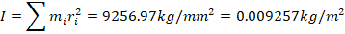
Lift performance
The lift fan specs should be higher than the required pressure to lift the hovercraft. From the AFB1212SH product attribute on DigiKey, it is specified that the maximum static pressure of the fan is 107.1 Pa. To calculate the pressure needed to lift the hovercraft, the following formula can be used.
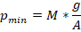
In the case of design 3, the required pressure is Pa. This is 68.5% of the maximum, which gives a reasonable margin of error. Since the fan can be given up to 13.8V, which will generate up to 141.6Pa, it will very easily be able to lift the hovercraft , which will generate up to 141.6Pa, it will very easily be able to lift the hovercraft and take only 51.78% of its max delivered pressure

Electrical system
Total system power consumption can be found by adding the power consumption of the different components. The fan power rating is taken from the datasheet whereas the rest is calculated with P=VI.
Component | Current (mA) | Voltage (V) | Power(W)
Lift fan | 530 | 12 | 6.36
Thrust fan | 455 | 12 | 5.5
Servo | 150 | 5 | 0.75
IR sensor*2 | 30 | 5 | 0.15
US sensor | 15 | 5 | 0.075
IMU | 3.9 | 5 | 0.0195
Controller | 20 | 5 | 0.1
 |  |  | 12.9545
Table 11: total power consumption of design 3
Discharge time of the battery represents how long the hovercraft can run. It is found as follows:
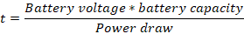
By applying the values for the Gens Ace 450mAh battery and the power draw found above, we find:
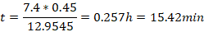

Propulsion Kinematics and Performance Metrics
The thrust fan uses Newtons Third law of motion, which states that every action produces an equal and opposite reaction. Since the fan is sucking air in, it also generates a forward force opposite the direction the air is being pushed toward.
The airflow generated by the thrust fan is 108.2 CFM = 0.05107 m³/s of air. The speed at which the air leaves the fan is found through v=Q/A, with A=pi/4(d_blade-d_hub)^2=0.00898m^2. v=0.05107/0.00898=5.69m/s.
To find the thrust force the following formula can be used F=kρQv, with rho being the air density constant 1.204kg/m^3 and k adjustment factor of 0.85 in this report. By plugging the values, F=0.85*1.204*0.05107*5.69=0.297N
Since the COM is at 16.3mm of the center on the x axis and the fan is at 128mm on the x axis, the distance between the two will help generate torque and angular motion.

Straight line motion
The formula to find the acceleration in a straight line can be found with Newton’s second law of motion. All the forces applied to the system are the thrust force and drag force, however since the hovercraft is floating and has minimal contact with the ground, and that it flies at low speed, the drag force can be ignored for the purpose of this report.. .
The time necessary to cross the straight line of 2.35m is:
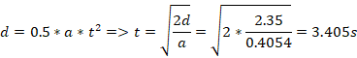

Angular motion
The angular acceleration can be found in the same way as in straight line motion, but the fan is turned at 90 degrees. The sum of force is the same and the formula to find the angular acceleration is as follows:
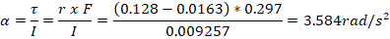
The time to do a turn of 90 degrees can be found with the following equation:
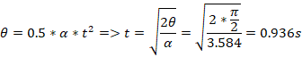

Quantity | Value

Total mass, M | 0.7326 kg
Centre of mass | (16.3, 0) mm
Moment of inertia, I | 0.009257 kg·m²
Pressure needed / fan maximum | 73.32 / 141.6 Pa (51.78 %)
Thrust force, F | 0.297 N
Linear acceleration, a | 0.4054 m/s²
Time for 2.35 m straight | 3.405s
Turning torque, τ | 0.03317 N·m
Angular acceleration, α | 3.585 rad/s²
Time for 90° turn | 0.936s
Battery run time | 15.42 min

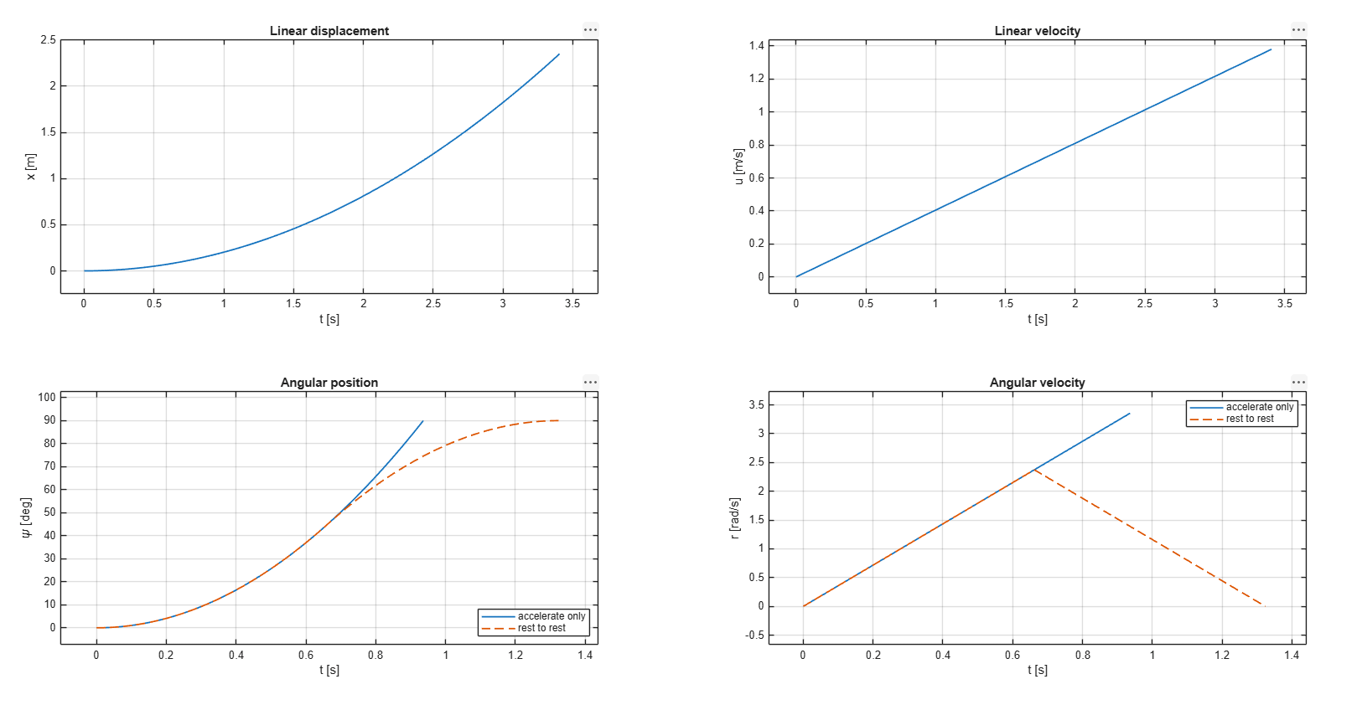
Design Selection
We developed three design alternatives and compared them using the competition requirements. First, we checked each design against the mandatory constraints. Any design that failed would be eliminated. We then used SWOT analyses to examine the remaining options and a Weighted Objectives Table (WOT) to compare them numerically. The WOT weights are also used in the Analytical Hierarchy Process (AHP) at the end of this section to check whether the same design comes out ahead.
The values in this section come from the latest design calculations for each alternative. For Design 3, we used the updated simulation (0.733 kg), which replaces the earlier 0.798 kg estimate. Where a value was missing but could be calculated from the available parameters, the calculation is included and the result is marked with an asterisk (*). All three designs use the same thrust fan (Sunon MEC0251V1, estimated static thrust of 0.297 N), lift fan (Delta AFB1212SH), and battery pack. This lets us focus the comparison on differences in geometry, mass distribution, and sensor placement.
Parameter | Design 1 | Design 2 | Design 3
Deck shape and size | 320 × 389 mm, rounded body | 360 × 240 mm, rectangular | 400 × 250 mm, R = 70 mm front corners
Thrust fan location | Front | Rear, x = −115 mm | Front, x = +128 mm
Steering servo and range | HS-311, ±90° | HS-311, ±90° | HS-422, ±90°
Counted sensors | 1 US + 2 IR | 1 US + 2 IR | 1 US + 2 IR
Counted components, N_{c} | 6 | 6 | 6
Total mass | 0.769 kg | 0.760 kg | 0.733 kg
Centre of mass (x, y) | (+19.7, 0) mm | (+3.0, 0) mm | (+16.3, 0) mm
Yaw moment of inertia, I_{zz} | 0.00859 kg·m² | 0.00883 kg·m² | 0.00926 kg·m²
Cushion area | 0.1039 m² | 0.0864 m² | 0.0980 m²
Required cushion pressure | 72.6 Pa | 86.3 Pa | 73.3 Pa
Share of fan maximum at 12 V (107.1 Pa) | 68 % | 81 % | 68 %
Maximum horizontal dimension (with skirt) | 408 mm (spin diameter) | 460.4 mm | 476 mm
Time for a 2.35 m straight from rest | 3.49 s* | 3.47 s | 3.41 s
90° turn, rest to rest | 1.21 s* | 1.26 s | 1.32 s*
Table 12: Key parameters of the three design alternatives (* derived in this section)
Design 1’s simulation gives 4.11 s for the 2.35 m straight, but that value includes drag, which the Design 2 and Design 3 values do not. It also reports a peak angular acceleration of about 4.3 rad/s² rather than a turn time. To compare all three designs on the same basis, we recalculated both from Design 1’s own values (a = 0.386 m/s²), with no drag and a rest-to-rest turn:
t_{2.35, D1} = √(2(2.35) / 0.386) = 3.49 s
t_{90°, D1} = 2√((π/2) / 4.3) = 1.21 s
For Design 3, the simulation gives an angular acceleration of 3.585 rad/s² and a 0.94 s turn under constant acceleration. To compare it fairly with Design 2, we use the rest-to-rest time, where the craft speeds up for the first 45° and slows down for the last 45°:
t_{90°, D3} = 2√((π/2) / 3.585) = 1.32 s

Constraint Screening
Constraint (source) | Design 1 | Design 2 | Design 3
Any horizontal dimension ≤ 480 mm during the run (competition rules) | Pass (408 mm) | Pass (460.4 mm) | Pass (476 mm)
Craft can rotate in place in a 500 mm lane (diagonal < 500 mm) | Pass | Pass | Pass
Lift fan can support the craft at its rated 12 V | Pass (68 %) | Pass (81 %) | Pass (68 %)
Fully autonomous: sensors drive the fans and servo | Pass | Pass | Pass
Fans fitted with safety nets | Pass | Pass | Pass
Table 13: Screening of the alternatives against the hard constraints
All three designs meet the listed constraints based on the current calculations, so we kept all of them for the SWOT and WOT analyses. However, Design 3 is only about 4 mm below the 480 mm size limit and could exceed it if the skirt expands more than expected. Design 1, at 408 mm, has the most room. Since the size limit is a pass/fail requirement, we did not include it as a separate WOT score. Instead, we considered the small margin in the SWOT analysis and in the improvements proposed for the selected design.

SWOT Analysis
We used SWOT analyses to compare the practical advantages and drawbacks of each design. Strengths and weaknesses are features we can change, such as the deck geometry, component placement, and sensor arrangement. Opportunities and threats come from outside the design, including the competition rules, track conditions, and available equipment. The factors common to all three designs are listed together below; the individual tables focus on what makes each design different.
Opportunities (all designs) | Threats (all designs)
- The IMU does not count toward N_{c}, so closed-loop heading hold and accurate turn angles do not increase the component count.  - Both fans are rated to 13.8 V. Driving the lift fan at 13.8 V through PWM raises its maximum pressure from 107.1 Pa to about 141.6 Pa (+32 %), a reserve for the 3 mm obstacle.  - Three attempts are allowed and only the best one counts, so parameters can be tuned between attempts.  - Sensor drivers (ultrasonic, timer, ADC) and the provided I²C driver already exist in the team’s code base.  - The parametric SolidWorks model allows components to be moved quickly to correct the centre of mass. | - The lane is only 50–55 cm wide, so every design has roughly 9 –12 cm of clearance per side and wall contact is likely.  - The 1, 2 and 3 mm obstacles span the full track width; a skirt that snags on the 3 mm obstacle ends the run.  - The bar and the exit are at random positions, so both must be detected by sensors; neither can be pre-programmed.  - Several masses are still estimates (controller 150 g, skirt, wiring). Any mass growth raises the required cushion pressure.  - Ambient light in the atrium can disturb the Sharp IR sensors.  - The fan supply arrangement still has to be confirmed with the lab technician, and one Arduino Nano has already failed.
Table 14: External factors common to all three alternatives

Design 1
Strengths | Weaknesses
- Lowest required pressure, 72.6 Pa or 68 % of the fan’s rated maximum, the best lift margin of the three, with a predicted 2.17 mm hover gap at 12 V.  - Fastest rotation: the lowest yaw inertia (0.00859 kg·m²) and a peak angular acceleration of about 4.3 rad/s² give a 1.21 s* rest-to-rest 90° turn.  - Rounded body and front-mounted thrust: the fan can pull the nose away from a wall after contact.  - Most compact footprint: 408 mm spin diameter, 72 mm under the 480 mm limit and 46 mm of clearance per side when rotating in a 500 mm lane.  - Nc = 6, symmetric batteries, and the longest predicted run time (20.2 min). | - The ultrasonic sensor faces forward and its orientation for the bar has not been decided, so the 15 % bar bonus is not yet covered.  - Centre of mass 19.7 mm ahead of the deck centre (5 % of the length), the most nose-heavy of the three.  - Widest body (320 mm), leaving 90 mm per side in a 500 mm lane when travelling straight.  - Slowest straight in its own simulation (4.11 s with drag; 3.49 s* without drag).  - Some values are still placeholders (IR sensor model, foam mass).
Opportunities | Threats
- Angling the ultrasonic sensor upward, as in Design 3, would cover the bar without adding a component.  - At 13.8 V the predicted hover gap rises from 2.17 mm to 3.77 mm, above the 3 mm obstacle.  - A parametric SolidWorks model of this geometry already exists, so components can be repositioned quickly. | - If the forward ultrasonic sensor must also find the bar, one sensor has two jobs and may do neither well.  - At an opening, the diagonal IR rays point into open space; an out-of-range reading must not be mistaken for a nearby wall.  - The front thrust jet passes over the lift-fan intake, which could reduce hover height while accelerating.
Table 15: SWOT analysis of Design 1

Design 2
Strengths | Weaknesses
- Quick rotation: the 118 mm lever arm gives 3.97 rad/s² and a 1.26 s rest-to-rest 90° turn.  - Narrowest body (260 mm), leaving 120 mm per side, and a 460.4 mm maximum dimension (19.6 mm margin).  - Centre of mass only 3 mm from the centre of lift, so the cushion pressure is even and the craft hovers level.  - Light (0.760 kg), with a 3.47 s straight, within 2 % of the fastest.  - Top IR sensor is placed ahead of the centre of mass, giving the craft room to brake and come to rest under the bar.  - N_{c} = 6. | - Smallest cushion area (0.0864 m²) gives the highest required pressure, 86.3 Pa or 81 % of the fan’s rated maximum.  - Rear vectoring pushes the tail sideways, so the lateral thrust accelerates the centre of mass toward the outside of the turn while the nose rotates inward. The craft skids toward the outer wall.  - Square deck corners. If a front corner touches a wall, the rear thrust keeps pressing it into the wall.  - A single side IR sensor watches only one wall, so lane centring and exit detection are one-sided.
Opportunities | Threats
- At 13.8 V the required pressure falls to 61 % of the fan’s maximum and the hover gap rises from 1.13 mm to 2.61 mm.  - The vectoring servo can hold a 19.7° trim to cancel the lift fan’s swirl torque. | - The predicted hover gap at 12 V is 1.13 mm, less than the 3 mm obstacle, so clearing it depends on fan overdrive and skirt flexibility.  - If the exit is on the unmonitored side, the 25 % bonus is lost.  - The upward IR sensor sees open space until the bar arrives, and an out-of-range IR reading can be mistaken for a target.  - Every 10 g of mass growth adds 1.1 Pa to the required pressure, the largest sensitivity of the three designs.
Table 16: SWOT analysis of Design 2

Design 3
Strengths | Weaknesses
- Front vectoring: the lateral thrust points into the turn, so the nose and the centre of mass both move toward the turn, and the fan can pull the nose off a wall after contact.  - Rounded front corners (R = 70 mm) slide along walls rather than catching on them.  - Two IR sensors angled at 45° see both walls: lane centring, openings on either side and the cue for each turn.  - The upward-angled ultrasonic sensor returns no echo until the bar, and sees it ahead of the craft, leaving room to brake.  - The elongated deck keeps 94 % of Design 1’s cushion area while being 40 mm narrower. It is also the lightest craft (0.733 kg), so it needs almost as little pressure as Design 1: 73.3 Pa (68 %). The low mass also gives the fastest straight (3.41 s).  - The bottom plate spreads the cushion air evenly and protects the skirt from the floor.  - N_{c} = 6, and the highest yaw inertia makes heading hold the least sensitive to disturbances such as lift-fan swirl. | - Highest yaw inertia (0.00926 kg·m²), so the rest-to-rest 90° turn takes 1.32 s, 5 % longer than Design 2.  - Only about 4 mm under the 480 mm limit with a 15 mm skirt bulge.  - Centre of mass 16.3 mm ahead of the deck centre (4.1 % of the deck length), so the cushion is slightly nose-heavy.  - The thrust fan’s jet passes over the deck toward the lift fan intake and the controller.  - No forward-facing range sensor. A 45° IR ray reaches the side wall only 0.16–0.19 m ahead, so the end wall is seen late and turns rely on detecting the side opening.
Opportunities | Threats
- Shortening the deck from 400 mm to 390 mm restores about 13 mm of size margin for only a 2.7 % rise in required pressure (75.3 Pa, 70 %).  - The batteries can move rearward in the parametric CAD model to pull the centre of mass back toward the centre of lift.  - 13.8 V lift-fan overdrive lowers the required share to 52 %. | - At an opening, the IR ray points into open space; an out-of- range reading must not be mistaken for a nearby wall.  - Skirt bulge beyond 15 mm would break the 480 mm rule.  - Every 10 g of mass growth adds 1.0 Pa to the required pressure.  - If the thrust jet disturbs the lift-fan intake, hover height drops while the craft is accelerating.
Table 17: SWOT analysis of Design 3

Key Observations
- Yaw inertia affects both stability and turning speed. A design with higher inertia is less easily disturbed, but it also takes longer to turn. Design 1 has the quickest turns, while Design 3 has the highest inertia and should be less sensitive to disturbances. To avoid counting inertia twice, the WOT scores turning performance directly and leaves heading correction to the IMU control loop.
- The position of the thrust fan also matters when the craft approaches a wall. The front-mounted fans in Designs 1 and 3 can pull the nose into a turn and help it move away from contact. Design 2 uses rear-mounted thrust, which pushes the craft toward the outside of a turn and may keep a front corner against the wall.
- A larger cushion area reduces the pressure needed for lift, but generally requires a wider deck. Design 1 has the greatest lift margin and the widest body. Design 2 is more compact but needs the most pressure. Design 3 provides 94 % of Design 1’s cushion area without being as wide, and because it is also the lightest, it needs almost the same pressure.
- Sensor placement matters more than the number of sensors for the bonus tasks. Design 3 uses three counted sensors to monitor both walls, detect the exit, and detect the bar. Design 2 also uses three, but its side sensing only covers one wall. Design 1 also uses three and watches both walls, but its ultrasonic sensor faces forward, so bar detection is not yet covered.
- The straight-line times are very similar. All three designs use the same thrust fan and their masses differ by less than 5 %, so the predicted times over 2.35 m are within 0.09 s.

WOT Analysis
We selected the WOT criteria based on the competition scoring equation:
S = d_{completed} / (N_{c} · t_{course}) × (1.15)_{bar} × (1.25)_{exit}
An unfinished run uses tcourse = 120 s, compared with approximately 30 s for a completed run. As a result, getting through the entire course matters much more than a small improvement in speed. For example, a craft that becomes stuck or cannot clear an obstacle loses at least three quarters of its potential score, while the predicted straight-line times differ by less than 3 %. We therefore prioritized factors that affect whether the craft finishes and earns its bonuses. Each criterion can be estimated now and checked on the prototype later. Mandatory constraints, including the 480 mm size limit, were already handled during screening and are not scored again.
# | Criterion | Definition and metric | Weight | Rationale for the weight
C1 | Obstacle clearance | Lift margin at the fan’s rated 12 V: 1 − p_{req} / 107.1 Pa | 0.20 | Failing to clear the 3 mm obstacle ends the run, cutting d_{completed} and setting t_{course} to 120 s.
C2 | Turning performance | Rest-to-rest 90° turn time | 0.20 | The course has at least four 90° direction changes; turns are where the craft is slowest and most likely to fail.
C3 | Wall-contact avoidance | Lateral clearance in a 500 mm lane, plus nose shape and thrust location | 0.15 | A craft that sticks to a wall does not finish; ranked below C2 because the IMU loop limits how often contact occurs.
C4 | Task sensing | Coverage of lane keeping, turn cues, bar detection and exit detection | 0.20 | Gates the bonuses, worth up to 44 % together (1.15 × 1.25), and the autonomy needed to finish at all.
C5 | Component count | N_{c} (fans, servo and all sensors except the IMU) | 0.15 | Directly in the denominator: going from 6 to 7 components costs 14 % of the score.
C6 | Straight-line speed | Time to cover a 2.35 m straight from rest | 0.10 | t_{course} is in the denominator, but the designs differ by under 3 %; kept to reward the thrust-to-mass ratio.
 | Total |  | 1.00
Table 18: WOT criteria, metrics and weights
We assigned the highest weights to obstacle clearance (C1), turning (C2), and task sensing (C4), since problems in any of these areas could prevent a successful run or cost a bonus. Wall-contact avoidance (C3) and component count (C5) received slightly lower weights. Straight-line speed (C6) received the lowest weight because the predicted differences are small. We did not add a separate stability criterion: both stability and turning performance depend on yaw inertia, so including both would give that parameter too much influence.
Each design receives a score from 0 to 10 for every criterion. For the numerical criteria, the best-performing design receives 10 and the others are scaled relative to it. For the two layout-based criteria, we used the scoring rules shown below.
Criterion | Scoring rule
C1 | 10 × margin_{i} / margin_{best}
C2 | 10 × t_{best} / t_{i}
C3 | Clearance sub-score 5 × c_{i} / c_{best} (c = clearance per side in a 500 mm lane), plus nose shape (rounded 2.5, square 1.0) and thrust location (front 2.5, rear 1.0)
C4 | Four functions (lane keeping, turn cue, bar, exit) at 2.5 if fully covered, 1.25 if partly, 0 if not; minus 0.5 for each function that relies on an IR reading into open space
C5 | 10 × N_{c,min} / N_{c,i}
C6 | 10 × t_{best} / t_{i}
Table 19: Scoring rules used in the WOT
The weighted score of design j is the sum of its criterion scores multiplied by the criterion weights:
WOT_{j} = Σ w_{i} s_{ij} (sum over the six criteria, i = 1 to 6)
Criterion | Weight | Design 1 score | Design 1 weighted | Design 2 score | Design 2 weighted | Design 3 score | Design 3 weighted
C1 Obstacle clearance | 0.20 | 10.0 | 2.00 | 6.0 | 1.20 | 9.8 | 1.96
C2 Turning performance | 0.20 | 10.0 | 2.00 | 9.6 | 1.92 | 9.1 | 1.82
C3 Wall-contact avoidance | 0.15 | 8.8 | 1.32 | 7.0 | 1.05 | 9.6 | 1.44
C4 Task sensing | 0.20 | 8.3 | 1.66 | 6.5 | 1.30 | 9.0 | 1.80
C5 Component count | 0.15 | 10.0 | 1.50 | 10.0 | 1.50 | 10.0 | 1.50
C6 Straight-line speed | 0.10 | 9.8 | 0.98 | 9.8 | 0.98 | 10.0 | 1.00
Total | 1.00 |  | 9.46 |  | 7.95 |  | 9.52
Table 20: WOT results
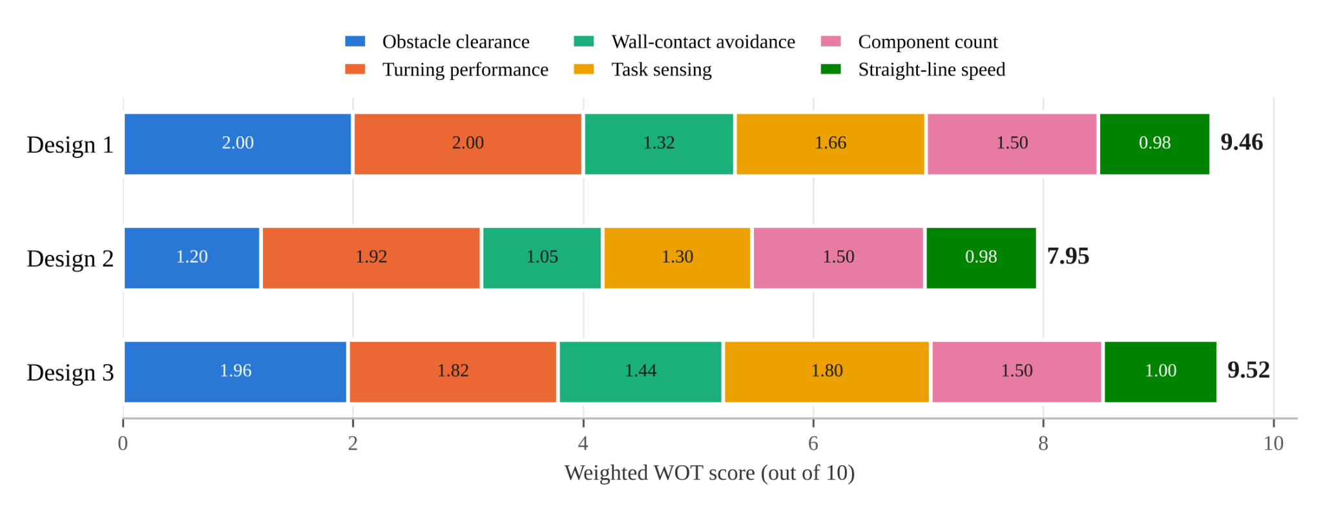
Figure 10: Weighted WOT score of each design, broken down by criterion
Design 3 has the highest total score at 9.52, with Design 1 close behind at 9.46 and Design 2 at 7.95. Designs 1 and 3 are nearly tied: Design 1 is better on lift margin and turning, while Design 3 is better on wall-contact avoidance and task sensing. The difference comes down mainly to task sensing. Design 3’s ultrasonic sensor is committed to detecting the bar, while Design 1’s sensor orientation for that task has not been decided. Design 2 trails because of its lift margin and its one-sided sensing.

Justification of Scores
C1 Obstacle clearance. The lift margins at the rated 12 V are 32.2 % for Design 1 (72.6 Pa required), 31.5 % for Design 3 (73.3 Pa) and 19.4 % for Design 2 (86.3 Pa). Scaling to Design 1 gives 10.0, 9.8 and 6.0. Designs 1 and 3 reach almost the same margin in different ways: Design 1 has the largest cushion area, while Design 3 has 6 % less area but is 36 g lighter. The 12 V rating was used for all three so that no design is credited with fan overdrive that the others could also use; at 13.8 V every design gains the same 32 % of pressure and the ranking does not change. Design 2’s lower score is consistent with its own hover-gap estimate of 1.13 mm at 12 V, which is below the 3 mm obstacle.
C2 Turning performance. The rest-to-rest 90° turn times are 1.21 s* (Design 1), 1.26 s (Design 2) and 1.32 s* (Design 3), giving 10.0, 9.6 and 9.1. The Design 1 and Design 3 simulations report angular acceleration and a constant-acceleration turn, so we converted both to rest-to-rest times to compare all three the same way. Design 1 turns fastest because it has the lowest yaw inertia (0.00859 kg·m²) and its thrust fan sits far ahead of the centre of mass. Design 3 has a similar lever arm (111.7 mm) but the highest inertia (0.00926 kg·m²), mainly from the controller at the rear end of a 400 mm deck.
C3 Wall-contact avoidance. The clearances per side in a 500 mm lane are 120 mm (Design 2, 260 mm wide), 110 mm (Design 3, 280 mm wide with skirt) and 90 mm (Design 1, 320 mm wide), giving clearance sub-scores of 5.0, 4.6 and 3.8. Designs 1 and 3 both have rounded fronts and front thrust, earning the full 5.0 geometry sub-score. Design 2 has a square deck and rear thrust and earns 2.0, because a front corner that touches a wall is pressed into it by the rear fan and its turning thrust pushes the craft toward the outer wall. The totals are 9.6 (Design 3), 8.8 (Design 1) and 7.0 (Design 2). Design 2 has the most room in the lane, but it is the design least able to recover once it touches a wall.
C4 Task sensing. Design 3 covers all four functions with its two 45° IR sensors (lane keeping on both walls, turn cue from the side opening, exit on either side) and its upward ultrasonic sensor (bar). It loses 0.5 for each of the two functions that depend on an IR ray pointing into an opening, for a score of 9.0. Design 2 covers lane keeping and exit detection only on one side (1.25 each), the turn cue fully with its forward ultrasonic sensor (2.5) and the bar with its upward IR sensor (2.5). It loses 0.5 each for the upward IR and the side IR reading into open space, for a score of 6.5. Design 1 covers lane keeping with its two diagonal IR sensors and the turn cue with its forward ultrasonic sensor (2.5 each), and detects the exit on either side with the IR sensors (2.5 − 0.5). The bar is only partly covered (1.25) because the ultrasonic sensor’s orientation for that task has not been decided, for a score of 8.3 (8.25 rounded).
C5 Component count. All three designs use two fans, one servo, one ultrasonic sensor and two IR sensors, for Nc = 6 and a score of 10.0. This criterion does not separate them, but it would penalize any design that added a sensor: going from 6 to 7 components costs 14 % of the score.
C6 Straight-line speed. The 2.35 m times are 3.41 s (Design 3), 3.47 s (Design 2) and 3.49 s* (Design 1), giving 10.0, 9.8 and 9.8. Design 1’s own simulation gives 4.11 s because it includes drag; the no-drag value is used here so that all three are compared the same way. The spread is only 0.09 s because the thrust is the same and the masses differ by under 5 %.

Kinematic Cross-Check
We also estimated an ideal travel time for each design using three 2.35 m straight sections and four 90° turns from rest to rest. This calculation ignores braking and sensor delays. We then combined the estimated time with the counted component total to obtain a simple kinematic score index:
t_{m} = 3 t_{2.35} + 4 t_{90°}, S_{index} = 1 / (N_{c} · t_{m})
Design | t_{m} (s) | N_{c} | S_{index} relative to Design 2
Design 1 | 15.30 | 6 | 1.01
Design 2 | 15.45 | 6 | 1.00
Design 3 | 15.51 | 6 | 1.00
Table 21: Ideal kinematic score index
Based only on these ideal motion calculations, the three designs are within about 1 % of each other: Design 1’s fast turns make up for its slower straight, and Design 3’s low mass makes up for its slower rotation. Kinematics alone therefore cannot separate them. The deciding factors are whether the craft completes the course and earns the bonuses, which is what the WOT weights most heavily.

Sensitivity of the Result
The ranking was tested against changes in the weights and the scoring:
- Raising or lowering any single weight by 0.05 (then renormalizing) leaves Design 3 first in every case, but its lead over Design 1 is as small as 0.01 points.
- With all six weights equal, Design 3 scores 9.58 against 9.48 for Design 1 and 8.15 for Design 2.
- If the 480 mm size margin is added as a seventh criterion with weight 0.10 (scored as 10 × min(1, margin / 20 mm)), Design 1 moves ahead with 9.51 against 8.77 for Design 3 and 8.13 for Design 2, because Design 3 is only about 4 mm under the limit. This is why the size margin is the first item in the strategy below.
The WOT therefore ranks Design 3 first, but only narrowly ahead of Design 1, and the order depends on how the size margin is treated. Design 3 is preferred because its sensor layout already covers both bonus tasks, and because its size margin can be restored by shortening the deck by 10 mm with almost no loss of lift margin. The AHP analysis at the end of this section starts from the same criterion weights and serves as an independent check on this close result.

Strategies for the Selected Design
Finally, we used the SWOT findings to identify changes to make before testing Design 3. The TOWS matrix below connects its strengths and weaknesses with the opportunities and threats identified earlier.
Strengths + Opportunities | Weaknesses + Opportunities
- Use the free IMU with the two 45° IR sensors for heading hold and lane centring, so the high yaw inertia works for the craft on straights.  - Use the three attempts to tune the bar-stop lead distance from the upward ultrasonic sensor. | - Shorten the deck from 400 mm to 390 mm: about 13 mm of size margin for a 2.7 % rise in required pressure.  - Move the batteries rearward in the CAD model to bring the centre of mass back toward the centre of lift.  - Keep 13.8 V lift-fan overdrive as a reserve for the 3 mm obstacle.
Strengths + Threats | Weaknesses + Threats
- Use the two IR sensors together: an opening is confirmed only when one side jumps out of range while the other still reads a wall, which rejects single out-of-range errors.  - Rely on the rounded front and front thrust to recover from wall contact instead of adding a bumper sensor. | - Raise the thrust fan or add a small deflector so its jet clears the lift-fan intake; verify hover height with the thrust fan on.  - Weigh every part as it arrives and update the mass budget; each 10 g costs 1.0 Pa of lift margin.  - Measure the inflated skirt bulge on the prototype before the competition and trim the deck if it exceeds 15 mm.
Table 22: TOWS strategies for Design 3

AHP Analysis
As a second check on the WOT result, we applied the Analytical Hierarchy Process (AHP). The AHP compares the options two at a time on Saaty’s 1 to 9 scale (1 = equal, 3 = moderately preferred, 5 = strongly preferred, with 2 and 4 as intermediate values) and converts each comparison matrix into priorities using its principal eigenvector. The hierarchy has the goal, the highest competition score, at the top, the six WOT criteria in the middle and the three designs at the bottom.

Criterion Weights
The criterion comparison matrix was built from the ratios of the WOT weights, so that each entry is a_{ij} = w_{i} / w_{j}. For example, obstacle clearance (0.20) is rated 2 against straight-line speed (0.10) and 1.33 against wall-contact avoidance (0.15). A matrix built this way is perfectly consistent (λ_{max} = 6, CR = 0), and its eigenvector returns the WOT weights exactly. Both methods therefore use the same priorities, and any difference in the result comes from how the designs are compared.
 | C1 | C2 | C3 | C4 | C5 | C6 | Weight
C1 | 1 | 1 | 1.33 | 1 | 1.33 | 2 | 0.20
C2 | 1 | 1 | 1.33 | 1 | 1.33 | 2 | 0.20
C3 | 0.75 | 0.75 | 1 | 0.75 | 1 | 1.5 | 0.15
C4 | 1 | 1 | 1.33 | 1 | 1.33 | 2 | 0.20
C5 | 0.75 | 0.75 | 1 | 0.75 | 1 | 1.5 | 0.15
C6 | 0.5 | 0.5 | 0.67 | 0.5 | 0.67 | 1 | 0.10
Table 23: Pairwise comparison matrix of the criteria

Design Comparisons
For each criterion, the three designs were compared in pairs using the values in Table 12 and the reasoning in the Justification of Scores section. Each judgment states how strongly the first design is preferred over the second; a value below 1 means the second design is preferred. The consistency of each matrix is checked with:
CI = (λ_{max} − n) / (n − 1), CR = CI / RI
where RI = 0.58 for a 3 × 3 matrix. A consistency ratio (CR) below 0.10 is considered acceptable.
Criterion | D1 vs D2 | D1 vs D3 | D2 vs D3 | D1 priority | D2 priority | D3 priority | CR
C1 Obstacle clearance | 3 | 1 | 1/3 | 0.429 | 0.143 | 0.429 | 0.000
C2 Turning performance | 1 | 2 | 1 | 0.413 | 0.327 | 0.260 | 0.046
C3 Wall-contact avoidance | 2 | 1/2 | 1/3 | 0.297 | 0.163 | 0.540 | 0.008
C4 Task sensing | 2 | 1/2 | 1/3 | 0.297 | 0.163 | 0.540 | 0.008
C5 Component count | 1 | 1 | 1 | 0.333 | 0.333 | 0.333 | 0.000
C6 Straight-line speed | 1 | 1 | 1 | 0.333 | 0.333 | 0.333 | 0.000
Table 24: Pairwise comparison of the designs for each criterion
The judgments were made as follows:
- C1: Designs 1 and 3 have almost the same lift margin (32.2 % and 31.5 %), so they are rated equal. Each is moderately preferred (3) over Design 2, whose 19.4 % margin and 1.13 mm hover gap put the 3 mm obstacle at risk.
- C2: The turn times differ by at most 9 %. Design 1 is slightly preferred (2) over Design 3, and the 4 % to 5 % gaps between neighbouring designs are rated equal.
- C3: Design 3 is slightly preferred (2) over Design 1 for its extra 20 mm of clearance per side with the same rounded front and front thrust. Both are preferred over Design 2 (3 for Design 3 and 2 for Design 1), because its square corners and rear thrust push it into the wall once it makes contact.
- C4: Design 3 is slightly preferred (2) over Design 1 because its bar detection is already assigned to the upward ultrasonic sensor, and moderately preferred (3) over Design 2, which senses lane keeping and the exit on one side only. Design 1 is slightly preferred (2) over Design 2.
- C5 and C6: All three designs have Nc = 6, and their 2.35 m times are within 0.09 s of each other, so every comparison is rated equal.

Synthesis
The overall priority of each design is the sum of its local priorities multiplied by the criterion weights:
P_{j} = Σ w_{i} p_{ij} (sum over the six criteria, i = 1 to 6)
Criterion | Weight | Design 1 | Design 2 | Design 3
C1 Obstacle clearance | 0.20 | 0.086 | 0.029 | 0.086
C2 Turning performance | 0.20 | 0.083 | 0.065 | 0.052
C3 Wall-contact avoidance | 0.15 | 0.045 | 0.025 | 0.081
C4 Task sensing | 0.20 | 0.059 | 0.033 | 0.108
C5 Component count | 0.15 | 0.050 | 0.050 | 0.050
C6 Straight-line speed | 0.10 | 0.033 | 0.033 | 0.033
Total | 1.00 | 0.356 | 0.235 | 0.410
Table 25: AHP weighted priorities of the designs
The AHP ranks the designs in the same order as the WOT: Design 3 (0.410), Design 1 (0.356) and Design 2 (0.235). All six design comparison matrices have a CR below 0.05. The gap between Designs 3 and 1 is wider than in the WOT because the 1 to 9 scale records even a slight preference as a 2:1 ratio, so the differences in task sensing and wall clearance count for more than they do under linear scaling. The larger AHP margin should therefore not be read as more certainty than the WOT provides; the useful result is that two different scoring methods give the same order.
The ranking also holds when the criterion weights are not taken from the WOT. With a criterion matrix filled in directly on the 1 to 9 scale (C1, C2 and C4 equal; each rated 2 over C3 and C5 and 3 over C6; C3 and C5 each rated 2 over C6; CR = 0.002), the priorities are 0.411, 0.361 and 0.229 for Designs 3, 1 and 2. With equal weights they are 0.406, 0.350 and 0.244, and changing any single weight by ±0.05 leaves Design 3 ahead by at least 0.044. Like the WOT, the AHP does not score the 480 mm size margin, which was handled during screening; the WOT sensitivity check showed that adding it as a criterion is the one change that would favour Design 1.

Progress to Date

Progress per Area
This section will discuss the current progress the team has achieved since the beginning of the semester towards the completion of the autonomous hovercraft. Work on the hovercraft can be divided into 5 primary areas.
- Research and Brainstorming
- Modeling and Simulation
- Construction
- Programming and Software Architecture
- Technical Documentation
For each primary area, members were divided to specialize into certain areas due to their experience and fluency leading up into the project. As the project advances and certain areas become complete, members will move into other areas to further accelerate progress.
 | Bryce | Elouan | Ethan | Minh-Tri | Parsa | Radmehr
Research and Brainstorming |  | ✔ | ✔ | ✔ | ✔ | ✔
Modeling and Simulation | ✔ | ✔ | ✔ |  |  | ✔
Construction | ✔ | ✔ | ✔
Programming and Software Architecture | ✔ |  |  | ✔ | ✔
Technical Documentation |  |  |  | ✔ |  | ✔
Table 26: Distribution of Primary Areas amongst Members
Within each area, progress has been made concurrently. Certain tasks within each area are interconnected, so being able to have work done on all areas simultaneously helps accelerate overall output.
For each area, they can be broken down into tasks to highlight key progress on the overall project:

Research and Brainstorming
After being presented with the project, preliminary research was conducted to gather information behind the workings of a hovercraft. From there, the design of 3 prototypes was completed such that the team as a collective could decide on the best design to implement for the course.
Particular focus was made on determining optimal hovercraft shape, number of components, and weight. After analyzing the scoring equation provided for the competition, an emphasis was placed on first completing the course at all, followed by the time taken to complete said course. While the number of components does contribute to the deduction of points, the value that each component provides saves development time and allows for more time to fine tune to hovercraft to further insure a completion of the course.
During the brainstorming session, 3 unique designs were proposed and initially analyzed for strengths and weaknesses of each. More detailed comparisons to determine the best design requires numerical analysis that could only be obtained through modeling and simulation.
With the theory researched, and the research and discussion done, this area can be viewed as complete.

Modeling and Simulation
Modeling and simulation of the hovercraft was achieved through the use of Solidworks and Matlab. Modeling the 3D visual of the hovercraft gives the team an opportunity to reflect on areas such as wiring the hovercraft, how the hovercraft might take turns in the course and the viability of component placements compared to the initial drawings. The simulation also provides key information about the structural integrity of each design, and where the weak points of each design are located.
The simulation provides theoretical values of key metrics such as mass, center of mass, propulsion kinematics, as well as linear and rotational dynamics. From these values, numerical analysis of each design can be performed, which could enable a more objective conclusion of the best hovercraft for the team.
As the models and simulations for each hovercraft have been done, this area can be viewed as complete.

Construction
With the choice of design made, the planning of the construction has commenced. As of now the team has looked at reviewing and acquiring necessary components for the project, while the actual construction of the hovercraft has been delayed until material provided from the lab technician could be obtained.
Therefore, this area can be viewed as starting.

Programming and Software Architecture
The software necessary for the functionality of the hovercraft has been a pivotal area of focus for the team from the beginning of the project. As of now, the team has aimed to develop drivers for all of the necessary comments, such as the infrared and ultrasonic sensors, the inertial measurement unit, the servo motor, etc. Additionally, register-level code was used to gain access to the Atmega328p’s Timer, ISR and ADC modules for use within the drivers and other utility functions.
The software architecture of the hovercraft has yet to be established, but generally a bare-metal approach using a finite-state diagram is going to be utilized to enable cleaner and traceable code to allow for easier debugging when needed. The codebase has also been modularized by component and microcontroller modules for ease of development and debugging. The codebase resides in a protected Github repository to allow the team access to the codebase while ensuring that only running and tested code is exposed to the main branch.
As the programming of the hovercraft is an ongoing task that will update up until the day of the competition, this area can be viewed as ongoing.

Technical Documentation
Throughout all 4 prior areas, it was imperative that sufficient documentation of each decision taken was justified for ease of traceability. That means that meeting meetings were attached to each meeting noting down each decision taken by the team and summarizing actionable steps for the following week. This can also be observed through comments attached to the codebase to provide context of each function and justification for any ambiguous lines of code. The use of Github also facilitates documentation and traceability, as each implementation is divided by branches, and each commit is signed by its author.
As technical documentation is a pivotal aspect of the entire life cycle of a project, this area can be viewed as ongoing.

Meeting
Meetings were aimed to be held once a week for a minimum of an hour each to ensure constant and up to date progress reports from each primary area. Meetings also allowed for planning about decisions to be taken and determining performance across the team. Meeting minutes were taken every week for documentation and traceability purposes.

Date | Description | Attendance
27/09/2026 | OHS safety quiz (Moodle module called Safety 1: Fall 2026-2027) and ENGR290 project room hand tool operation, and health and safety quiz (10q) within the ENGR-290 moodle module in week 25 October - 31 October need to be completed by TONIGHT  Big picture steps of what needs to be to build a hovercraft will be done to allow us to have an idea of the work required, and allow people to specialize in specific steps  Github Repo created to house arduino code/MATLAB simulink simulations  Equipment for techincal assignment will be gathered tomorrow after class (Ideally if lab tech answers on time) | Bryce, Elouan, Ethan, Minh-Tri, Parsa, Radmehr
04/10/2026 | Big picture tasks as of now  - Research  - Design and Modeling  - MatLab simulations  - Coding  - Technical Documentation  Distribution of who does what will be done soon. Lmk if you have any preferences  Health and Safety quiz to be completed before we return from break.  Github repo created  Designs by everyone should be done before next sunday. Ideally lets try to meet on Thursday to present our designs | Bryce, Elouan, Ethan, Minh-Tri, Parsa, Radmehr
08/10/2026 | Going with Elouan's design as of now with the modification that IR sensors are placed 90* apart as opposed to 180*  Parsa has experience implementing smooth turning rather than 90* turns  Rad and Ethan will get started on Simulink research and implementation  Elouan will update Bryce about the design and both will move towards 3d modelling  IR sensor bug needs to be resolved as soon as possible. Tomorrow maybe go to IEEE this Friday to get it resolved | Elouan, Ethan, Minh-Tri, Parsa, Radmehr
22/10/2026 | PDR document should include all three designs proposed alongside Matlab Calculations  We should figure out how much power the fans are drawing since they are going to heavily influence what kind of battery we use  There are 3 types of analysis that needs to be done (SWOT, AHP, WOT)  PDR Report should look to be around 60-70 pages, so everyone should contribute and expect to write ~10 pages each  What we need now:  Simulation of all hovercraft designs with (Center of Mass, Linear Motion, Solidwork model, Total Mass, Stability, Moment of Intertia, Max Angular Acc., Max Linear Acc.)  Table of Content can be analyzed from the moodle example and those who aren't heavily involved in the simulation work will do the bulk of the non trivial writing | Bryce, Elouan, Minh-Tri, Parsa, Radmehr
29/10/2026 | PDR REPORT AND PRESENTATION DUE MONDAY !!!  Everyone's part of the report has already been divided. Make sure you look at it and get start ASAP  Minh-Tri and Parsa have the less technically demanding parts in case some people need help with writing  PDR Presentation slides are divided as follows:  Requirements (Parsa) -> All three designs (Ethan, Rad, Elouan in ordder) -> Decision Selection (SWOT, WOT, and AHP) (Bryce) -> Specification (Elouan but Presented by Bryce) -> Progress and Schedule (Minh-Tri)  Make sure you have your respective slides ready by Sunday to practice  Time allocation for the presentation will be as follows  Requirements (40 seconds)  Design 1 (50 seconds)  Design 2 (50 seconds)  Design 3 (50 seconds  Decision Selection (30 seconds)  Specification (30 seconds)  Progress and Schedule (45 seconds)  These times are extremely strict, if we go over 5 minutes without finishing we get immediately cut off, practice beforehand to make sure you are under the time  Residual 10 Seconds to give us leeway in case someone goes over  Bryce's slide is dependent on the values extracted from the PDR Report, but during the presentation he wont necessarily be needing to say the numbers so Bryce should be fine to just create a 30s presentation of "based off blahblahblah we choose blahblahblah because of blahblahblah"  Meeting Sunday Online around 10-11am to practice the presentation. Probably around 1-1.5h to just make sure we're able to stick to the 5min time limit. Afterwards continue to lock in for the Report | Bryce, Elouan, Ethan, Minh-Tri, Parsa, Radmehr
Table 27: Meeting Minutes since the Start of the Project

Project Management
Project management has been structured in an agile methodology, to allow for sprints that push members to focus on key aspects of the hovercraft’s design sequentially. So while each area could work concurrently, the greater workload aims to tackle the hovercraft in more digestible chunks. The primary sprints of the hovercraft constructed as follows:
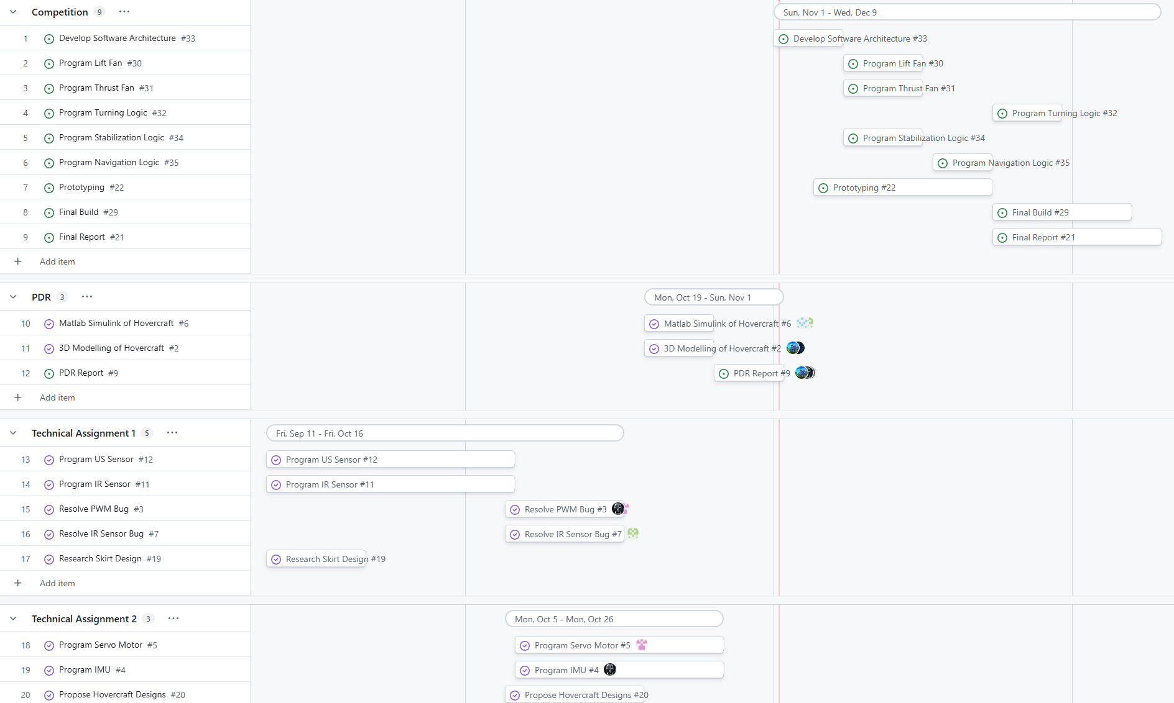
Figure 11: Gantt Chart of the Hovercraft Project
Sprint dates were determined using actionable class submissions to group workload towards certain course expectations.

Current Status
As of now the team is transitioning from the PDR sprint to the Competition sprint. This sprint signals the end of the Research and Brainstorming, and Modeling and Simulation team and the introduction of Construction as an area of focus. This transition subsequently places a larger demand on the Programming team, since the programming will now introduce the development of the software architecture as well as the programming of an entire integrated system.

Historical Performance
Up to now, the team has been making significant progress towards completing the project. The Modeling and Simulation sub-team notably seemed to complete their tasks more efficiently compared to the programming sub-team. The programming sub-team seemed to face challenges notably around the debugging of the drivers and equipment. This could be explained by lesser experience in programming using register-level logic as well as less man-power, as the brunt of the man-power was distributed to other sub-teams. Moving into the Competition sprint, additional members will be contributing to the programming sub-team to help accelerate progress.

Summary
The project aims to build and program an autonomous hovercraft capable of navigating, and exiting, a maze. Scoring of the project is done through the equation
$Score = \frac{d_{completed}}{N_{C}*t_{course}}$
Where $d_{completed}$, denotes the distance completed by the hovercraft, $N_{C}$ denotes the number of components, and $t_{course}$ denotes the time it takes for the hovercraft to exit the course.
From this equation, the team unanimously decided to place an emphasis on ease of development and optimized for the time variable through the following priorities for the hovercraft
- Finish the maze at all
- Finishing the maze in the shortest amount of time
- Finishing the maze with as little components as possible
Subsequently, the team produced 3 designs all of which looked to minimize weight on moment of inertia to allow for faster turns. From these designs, initial feedback was proposed and finally a simulation and modeling of all 3 designs were done to be able to extract quantitative measures for each design. Following an analysis of each design - SWOT, WOT and AHP analysis - it was found that Design 3 was the strongest design from the 3 and was chosen to be built for the competition.
Up until now the work has been divided into 5 areas of focus, with each member being assigned 2 areas of focus based on their prior experiences and fluencies. Weekly meetings have been held consistently and show steady progress towards the completion of the project. With the transition from the PDR sprint to the Competition sprint, redistribution of members has been performed due to the ending of two areas of focus and the increased demand from a third.
With the current state of the project and the historical performance of each team, the project should be completed by competition day given extra man-power be distributed to the programming sub-team.

